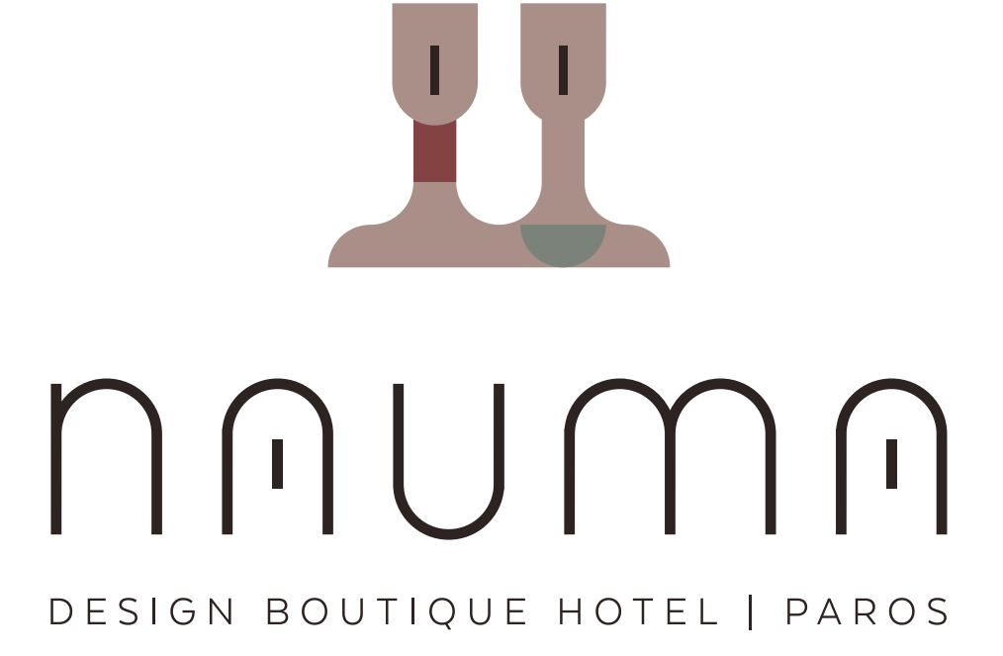

Job Title: Front Office Manager – Nauma Design Boutique Hotel Paros
About Us:
Nauma is a unique and intimate boutique hotel located in Naoussa Paros. We pride ourselves on offering a highly personalized and memorable experience for every guest. We are seeking a passionate and dynamic Front Office Manager to lead our front-of-house team and embody our commitment to exceptional service.
The Role:
As the Front Office Manager, you will be the face of our guest experience. You will oversee all front desk operations, ensuring every guest feels welcomed, valued, and well-cared for from arrival to departure. You will lead, mentor, and inspire your team to deliver consistently outstanding service that reflects the boutique character of our hotel.
Key Responsibilities:
- Manage and supervise all front office staff, including Guest Service Agents and other front-of-house roles.
- Ensure all guest requests and concerns are handled with professionalism and efficiency, turning them into positive experiences.
- Oversee daily front desk operations, including check-ins, check-outs, reservations, and billing.
- Develop and maintain the highest standards of service, guest satisfaction, and hotel presentation.
- Handle administrative duties such as staff scheduling, performance reviews, and managing the front office budget.
- Collaborate with other hotel departments, such as housekeeping and reservations, to ensure seamless guest service.
- Maintain a strong knowledge of the hotel's amenities and local area to assist guests with inquiries and recommendations.
- Ensure that the Hotel Manager is kept fully aware of any relevant feedback from guests and other departments
- Follow company brand standards

Qualifications and Skills:
- Bachelor's degree in Hospitality Management or related field.
- Proven experience in a front office or management role, preferably in a boutique or luxury hotel setting.
- Fluency in English. Knowledge of other languages is a plus
- Exceptional leadership and team-building skills.
- Outstanding communication and interpersonal abilities.
- Strong problem-solving and conflict-resolution skills.
- Proficiency with hotel management software and reservation systems.
- A genuine passion for hospitality and creating memorable guest experiences.
- Ability to work in a fast-paced environment and handle multiple priorities effectively.
What We Offer:
- A supportive and collaborative work environment in a beautiful boutique setting.
- Competitive salary and benefits.
- Accommodation, social insurance and meals are also provided.
- Opportunities for professional development and growth.
- The chance to make a significant impact on the guest experience and be a key part of a growing hotel.
To Apply:
Please submit your resume and a cover letter outlining your experience and why you are the ideal candidate for this role to: hello@hotelheart.gr

